March
2021
Happiness & Kindness
Use the ideas and suggestions in this winter months calendar to improve your wellbeing and connect to others. You can fill in the blanks yourself, with your own thoughts and ideas.  View and edit this document in Word on your computer, tablet, or phone. You can edit text; easily insert content such as pictures, shapes, and tables; and seamlessly save the document to the cloud from Word on your Windows, Mac, Android, or iOS device. | 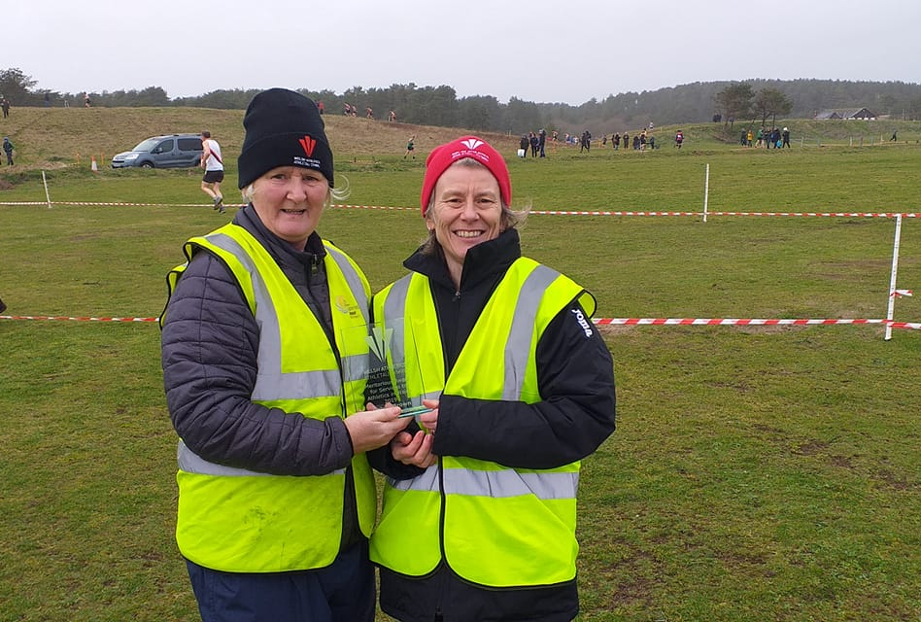
Sunday | Monday | Tuesday | Wednesday | Thursday | Friday | Saturday
 | 1 | 2 | 3 | 4 | 5 | 6
 | Virtual #FromMyDoor event – Walk/Jog/Run Tag | Take a selfie photo with your Official kit / WA pins badges Tag @WelshAthletics #Unite | Watch the ‘In conversation with Nigel Jones’ 19:30pm | You could start a journal about things you are grateful for |  | Share your favorite films/programmes of 2021 with your neighbours - and find out what they recommend
7 | 8 | 9 | 10 | 11 | 12 | 13
Join our WA #Unite Virtual Officials & Volunteers conference 12-4:30pm |  |  | Try a new recipe |  | Love the planet - plant some spring seeds | Get back in touch with an old friend you’ve not spoke to in a while
14 | 15 | 16 | 17 | 18 | 19 | 20
 | Help your community - donate unused IT equipment |  | Love the planet - litter pick on your street or walking route | Join our Coffee Connect Chat 6-7pm | Tell your loved ones why they are special to you
21 | 22 | 23 | 24 | 25 | 26 | 27
 |  | Do an act of kindness to make life easier for someone else |  | Organise a virtual tea break with friends |  | Send an encouraging note to someone who needs a boost
28 | 29 | 30 | 31
Make an effort to have a friendly chat with a neighbour | Help your community -donate to a food bank |  | Think of three activities that you want to do next month. How can you make sure that you do them?

